Vendor: Oracl
Exam Code: 1Z0-8
Exam Name: Java SE 8 Programmer I
Question 1—Question 10
QUESTION 1

Given:
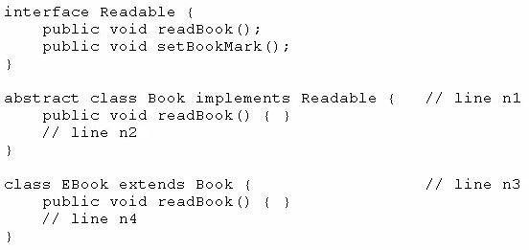

Which option enables the code to compile?
- Option A
- Option B
- Option C
- Option D

Answer: D

QUESTION 2

Given the code fragment:
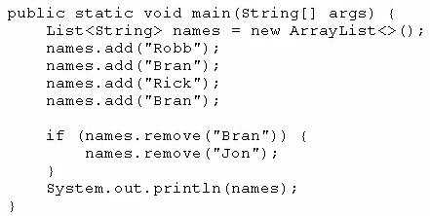

What is the result?
- [Robb, Rick, Bran]
- [Robb, Rick]
- [Robb, Bran, Rick, Bran]
- An exception is thrown at runtime.

Answer: A
Explanation:

After adding elements to names we have a list with four elements and element “Bran” repeated.
After removing element “Bran” we have a list with three elements [Robb, Rick, Bran]. remove method removes the first occurrence of the specified element from this list, if it is present. If the list does not contain the element, it is unchanged.

QUESTION 3

Given:
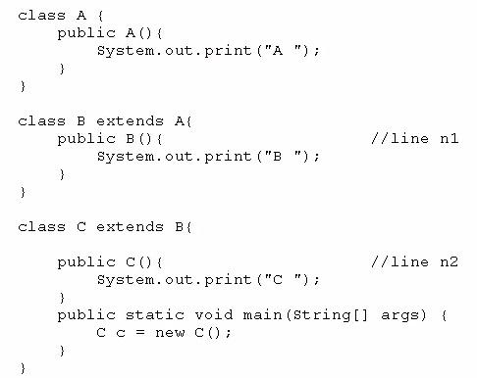

What is the result?
- C B A
- C
- A B C
- Compilation fails at line n1 and line n2

Answer: C

QUESTION 4

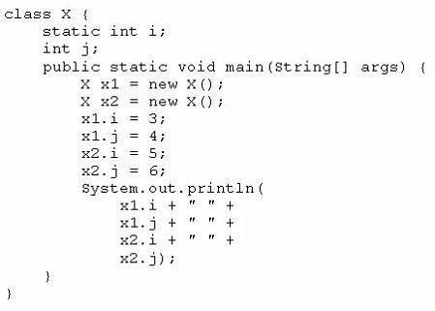
Given:

What is the result?

- 3 4 5 6
- 3 4 3 6
- 5 4 5 6
- 3 6 4 6

Answer: C

Explanation:

Since variable i is static, it is shared by all instances of X. When code executes x2.i = 5, x1.i = 5 too.

Since variable j isn’t static, each instance of X has its own copy of j.

QUESTION 5

Given the code fragment:
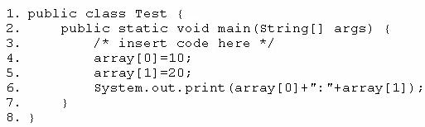

Which code fragment, when inserted at line 3, enables the code to print 10:20?
- int[] array = new int[2];
- int[] array; array = int[2];

- int array = new int[2];
- int array [2] ;

Answer: A

QUESTION 6

Given the code fragment:
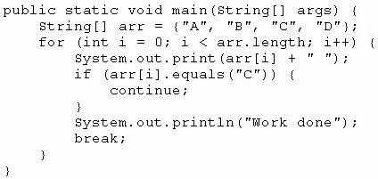

What is the result?
A. A B C Work done
- A B C D Work done
- A Work done
- Compilation fails

Answer: C

QUESTION 7

Which three are advantages of the Java exception mechanism?

- Improves the program structure because the error handling code is separated from the normal program function

- Provides a set of standard exceptions that covers all the possible errors

- Improves the program structure because the programmer can choose where to handle exceptions

- Improves the program structure because exceptions must be handled in the method in which they occurred

- Allows the creation of new exceptions that are tailored to the particular program being created

Answer: ACE
Explanation:

B is false. Standard exceptions not cover all possible errors.

D is false. Exceptions don’t have to be handled in the method in which they occurred.

QUESTION 8

Given the code from the Greeting.Java file:

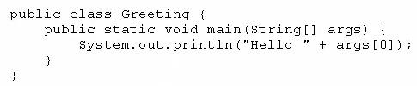

Which set of commands prints Hello Duke in the console?

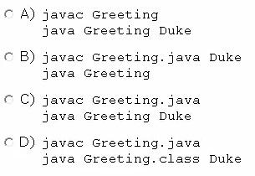

- Option A
- Option B
- Option C
- Option D

Answer: C

Explanation:

Source code file names must have .java suffixes to compile with javac We interpret or run the program with “java <class name without suffix> arguments”

QUESTION 9
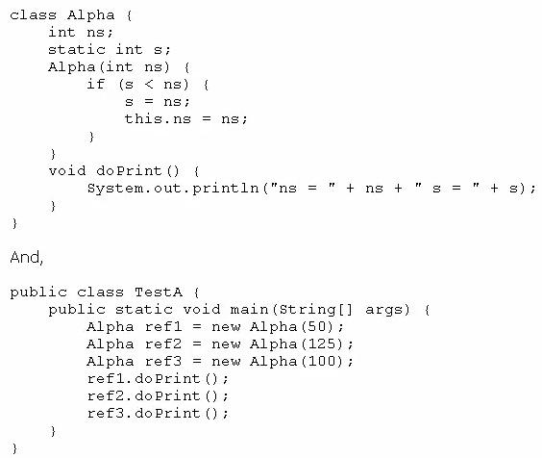
Given:

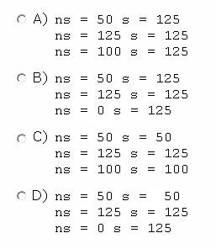
What is the result?

- Option A
- Option B
- Option C
- Option D

Answer: D

QUESTION 10
Given the code fragment:

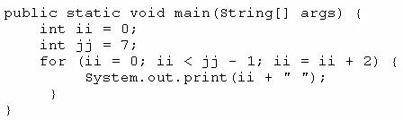

What is the result?
- 2 4
- 0 2 4 6
- 0 2 4
- Compilation fails

Answer: C

Question 11—Question 20

QUESTION 11

Given the code fragment:
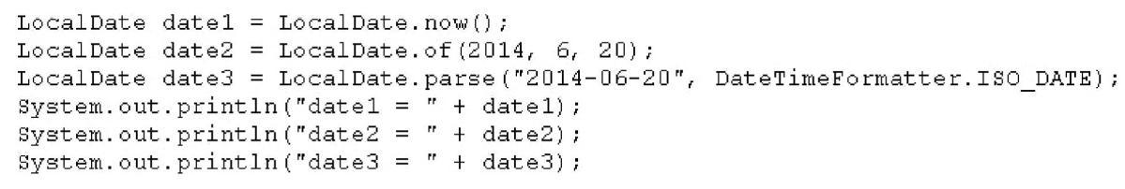

Assume that the system date is June 20, 2014. What is the result?
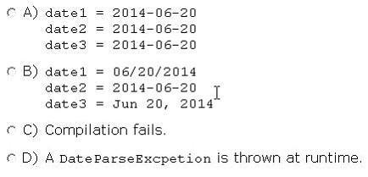

- Option A
- Option B
- Option C
- Option D

Answer: A

Explanation:

I've run the following code without any problem
import java.time.LocalDate;

import java.time.format.DateTimeFormatter;

public class Main {

public static void main(String[] args) {

LocalDate date1 = LocalDate.now();

LocalDate date2 = LocalDate.of(2014, 6, 20);

LocalDate date3 = LocalDate.parse("2014-06-20", DateTimeFormatter.ISO_DATE);

System.out.println("date 1 = " + date1);

System.out.println("date 2 = " + date2);

System.out.println("date 3 = " + date3);

}
}

The output is:
date 1 = 2015-09-05 (because run today, but problem statement says we must assume that

the system data is June 20, 2014)

date 2 = 2014-06-20

date 3 = 2014-06-20

QUESTION 12

Given the code fragment:
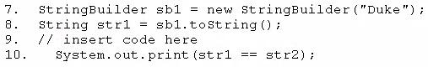

Which code fragment, when inserted at line 9, enables the code to print true?

- String str2 = str1;

- String str2 = new String (str1);

- String str2 = sb1. toString ();

- String str2 = "Duke";

Answer: A

Explanation:

Operator == checks if two things are EXACTLY the same thing, not if they have the same content

QUESTION 13

Given the code fragment:

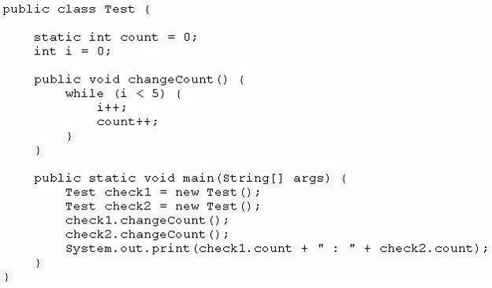

What is the result?

- 10 : 10
- 5 : 5
- 5 : 10
- Compilation fail

Answer: A

Explanation:

The variable i is local to all instances of class Test so each time we create an instance, i=0 and the loop add 5 to count.

The variable count (static) is global to all instances of class Test and all instances share the same variable. It's been initialized only once to zero an retains its value between the calls to changeCount

Since we call two times the method changeCount, the final result is 10 : 10

QUESTION 14

Given the code fragment:
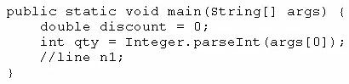

And given the requirements:

- If the value of the qty variable is greater than or equal to 90, discount = 0.5

- If the value of the qty variable is between 80 and 90, discount =0.2

Which two code fragments can be independently placed at line n1 to meet the requirements?

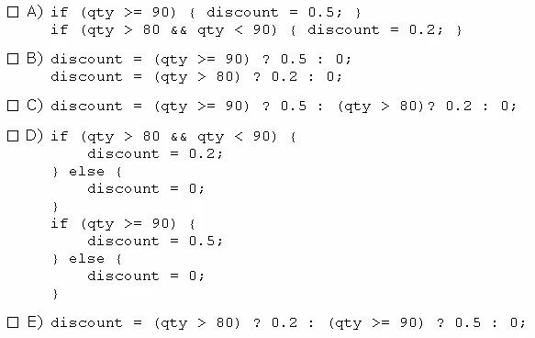

- Option A

- Option B

- Option C

- Option D

- Option E

Answer: AC

QUESTION 15

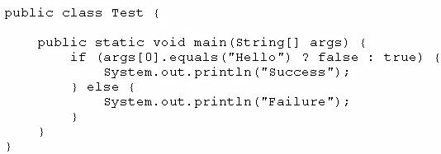
Given:

And given the commands:

javac Test.Java

Java Test Hello

What is the result?

- Success

- Failure

- Compilation fails.

- An exception is thrown at runtime

Answer: B

QUESTION 16

Which three statements describe the object-oriented features of the Java language?

- Objects cannot be reused.

- A subclass can inherit from a superclass.

- Objects can share behaviors with other objects.

- A package must contain more than one class.

- Object is the root class of all other objects.

- A main method must be declared in every class.

Answer: BCE

Explanation:

QUESTION 17
Given the following code:
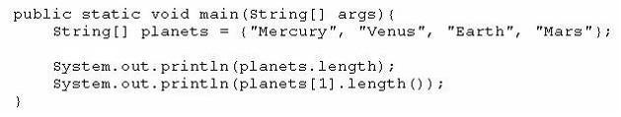

What is the output?

  - 4 4

  - 3 5

  - 4 7

  - 5 4

  - 4 5

  - 4 2

Answer: E

QUESTION 18

You are developing a banking module.

You have developed a class named ccMask that has a maskcc method.

Given the code fragment:
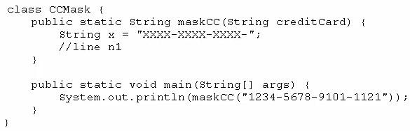

You must ensure that the maskcc method returns a string that hides all digits of the credit card number except the four last digits (and the hyphens that separate each group of four digits).

Which two code fragments should you use at line n1, independently, to achieve this requirement?
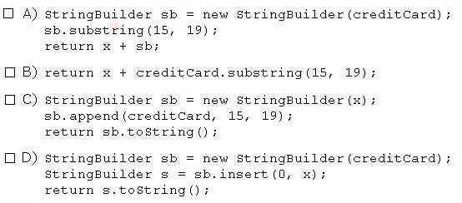

- Option A

- Option B
- Option C

- Option D

Answer: BC

QUESTION 19

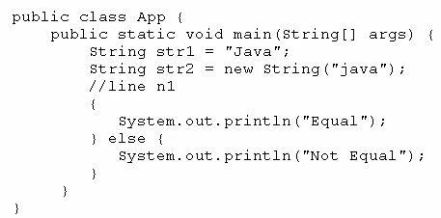
Given the code fragment:

Which code fragment, when inserted at line n1, enables the App class to print Equal?

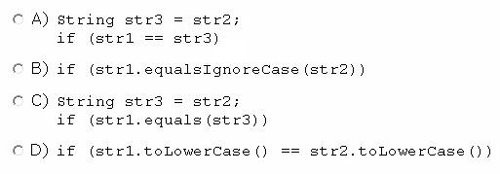

- Option A

- Option B

- Option C

- Option D

Answer: B

QUESTION 20
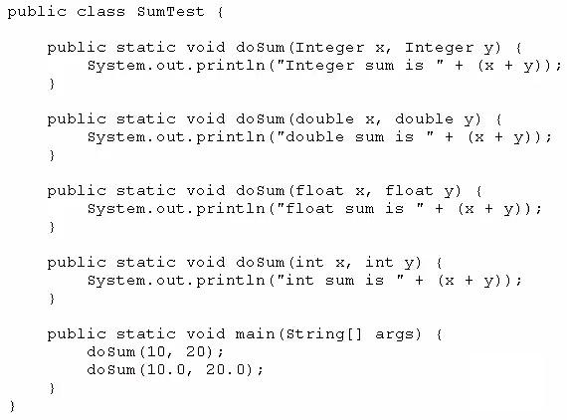
Given:

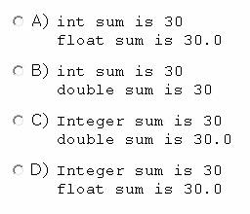
What is the result?

- Option A

- Option B

- Option C

- Option D

Answer: B

Explanation:

int is a primitive type and Integer is an object with an int. When we call doSum(10, 20), we are calling doSum(int, int).

By default, Java use double to represent its floating point literals. When we call doSum(10.0, 20.0), we are calling doSum(double, double)

Question 21—Question 30
QUESTION 21

Given the code fragment:
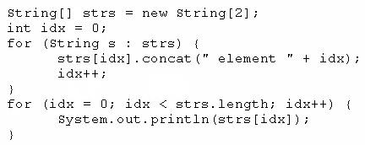

What is the result?

- Element 0 Element 1

- Null element 0 Null element 1

- Null Null

- A NullPointerException is thrown at runtime.

Answer: D

QUESTION 22

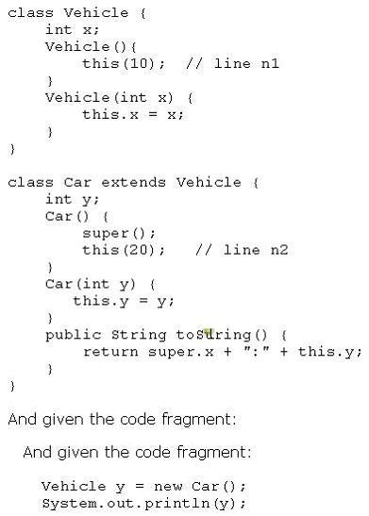
Given:
What is the result?

- 10:20

- 0:20

- Compilation fails at line n1

- Compilation fails at line n2

Answer: D

Explanation:

this() and super() can't be used in the same constructor

Here is a good reference for the question

http://stackoverflow.com/questions/10381244/why-cant-this-and-super-both-be-used-

together-in-a-constructor

QUESTION 23

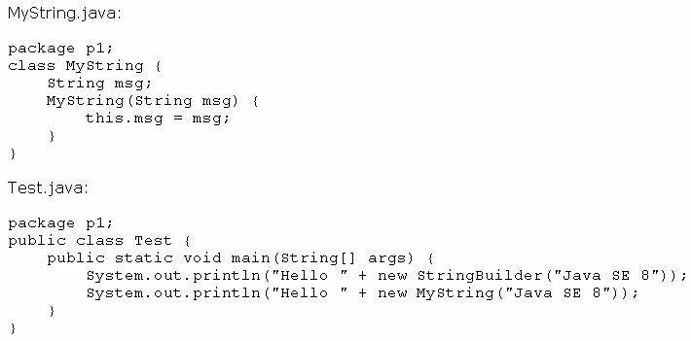
Given the definitions of the MyString class and the Test class:

What is the result?
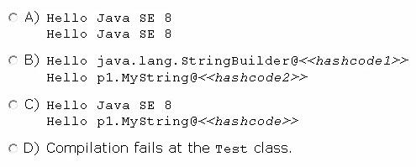

- Option A
- Option B
- Option C
- Option D

Answer: C
QUESTION 24

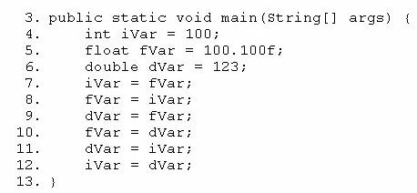
Given the code fragment:

Which three lines fail to compile?

- Line 7

- Line 8
- Line 9

- Line 10

- Line 11

- Line 12

Answer: ADF

Explanation:

QUESTION 25

Given:
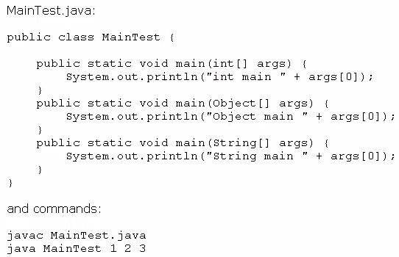

What is the result?

- int main 1
- Object main 1
- String main 1
- Compilation fails
- An exception is thrown at runtime

Answer: C

Explanation:

All methods have the same name but different signature since the parameters are different.

There is no problem with that.

JVM will call the method with signature “public static void main(String[] args)”

QUESTION 26

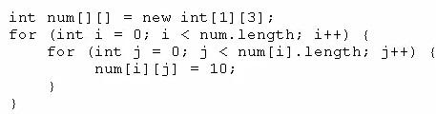
Given the code fragment:

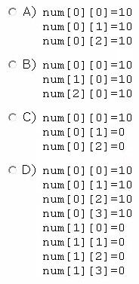
Which option represents the state of the num array after successful completion of the outer loop?

- Option A

- Option B

- Option C

- Option D

Answer: A

Explanation:

At first look we can exclude option D because the number of elements in the array is 3, the result of multiplying the two array dimensions 1 x 3.

We can run the code:

public class Main {
public static void main(String[] args) {

int num[][] = new int[1][3];

for (int i=0; i<num.length; i++) {

for (int j=0; j<num[i].length; j++) {

num[i][j] = 10;

System.out.println("num[" + i + "][" + j + "]= " + num[i][j]);

}

}

}

}

the output is:

num[0][0]= 10

num[0][1]= 10

num[0][2]= 10

QUESTION 27

Given the code fragment:
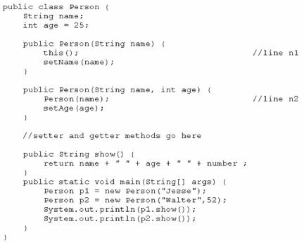

What is the result?

- Jesse 25

Walter52

- Compilation fails only at line n1

- Compilation fails only at line n2

- Compilation fails at both line n1 and line n2

Answer: D

Explanation:

At line n1, Person class hasn’t any constructor without arguments.

At line n2, there isn’t any method Person. If we want to call the constructor that should be “this(name)”.

QUESTION 28

Given the following code for a Planet object:
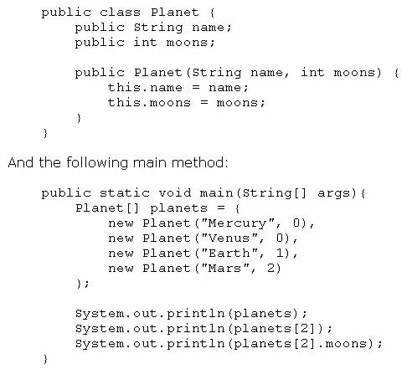

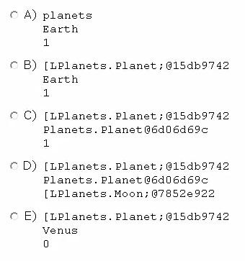
What is the output?

- Option A

- Option B

- Option C

- Option D

- Option E

Answer: C

QUESTION 29

You are asked to develop a program for a shopping application, and you are given the following information:
-The application must contain the classes Toy, EduToy, and consToy.

-The Toy class is the superclass of the other two classes.

-The int caicuiatePrice (Toy t) method calculates the price of a toy.

-The void printToy (Toy t) method prints the details of a toy.
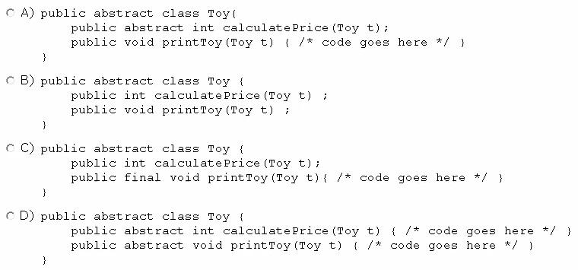

- Option A

- Option B
- Option C

- Option D

Answer: A

QUESTION 30
Given the following code:

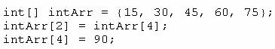

What are the values of each element in intArr after this code has executed?

- 15, 60, 45, 90, 75

- 15, 90, 45, 90, 75

- 15, 30, 75, 60, 90

- 15, 30, 90, 60, 90

- 15, 4, 45, 60, 90

Answer: C

Question 31—Question 40

QUESTION 31

Given the following array:

Which two code fragments, independently, print each element in this array?
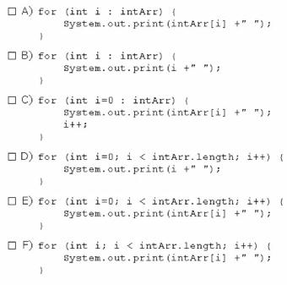

- Option A

- Option B

- Option C

- Option D

- Option E

- Option F

Answer: BE
Explanation:

QUESTION 32

Given the content of three files:

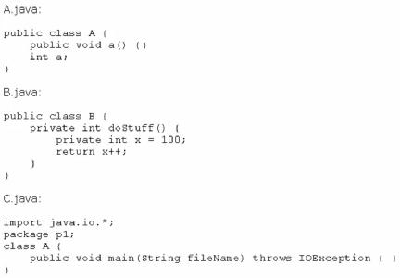

Which statement is true?

- Only the A.Java file compiles successfully.

- Only the B.java file compiles successfully.

- Only the C.java file compiles successfully.

- The A.Java and B.java files compile successfully.

- The B.java and C.java files compile successfully.

- The A.Java and C.java files compile successfully.

Answer: A

Explanation:

Class B doesn’t compile because we can’t use access modifiers (private) inside methods. Class C doesn’t compile because if the class is part of a package (p1), the package statement must be the first line in the source code file, before any import statements (java.io.*) that may be present.

QUESTION 33

Given the code fragment:
int[] array = {I, 2, 3, 4, 5};

And given the requirements:

- Process all the elements of the array in the order of entry.

- Process all the elements of the array in the reverse order of entry.

- Process alternating elements of the array in the order of entry.

Which two statements are true?

- Requirements 1, 2, and 3 can be implemented by using the enhanced for loop.

- Requirements 1, 2, and 3 can be implemented by using the standard for loop.

- Requirements 2 and 3 CANNOT be implemented by using the standard for loop.

- Requirement 1 can be implemented by using the enhanced for loop.

- Requirement 3 CANNOT be implemented by using either the enhanced for loop or the standard for loop.
Answer: BD

QUESTION 34

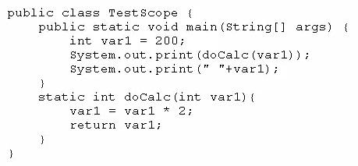
Given:

What is the result?

- 400 200

- 200 200
- 400 400

- Compilation fails.

Answer: A

QUESTION 35

Given the following class declarations:

- public abstract class Animal

- public interface Hunter

- public class Cat extends Animal implements Hunter

- public class Tiger extends Cat

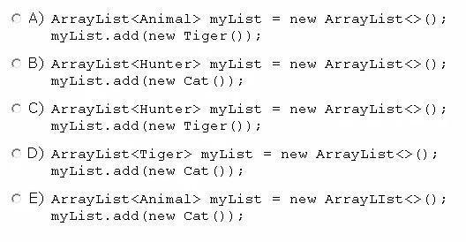
Which answer fails to compile?

- Option A

- Option B

- Option C

- Option D

- Option

Answer: D

Explanation:

Cat cannot be converted to Tiger.

One Tiger is a Cat but one Cat isn't a Tiger.

QUESTION 36

Which statement is true about Java byte code?

- It can run on any platform.

- It can run on any platform only if it was compiled for that platform.

- It can run on any platform that has the Java Runtime Environment.

- It can run on any platform that has a Java compiler.

- It can run on any platform only if that platform has both the Java Runtime Environment and a Java compiler.

Answer: C

Explanation:

We are talking about byte code so the Java program has been compiled. The question ask for what we need to run the byte code.

QUESTION 37

Given:
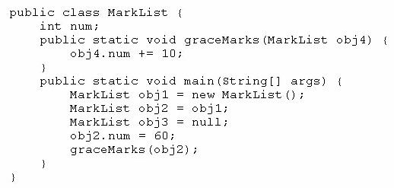

How many MarkList instances are created in memory at runtime?

- 1

- 2

- 3

- 4

Answer: A
Explanation:
Only the statement “MarList obj1 = new MarkList();” creates an instance of MarkList.

QUESTION 38

Given:
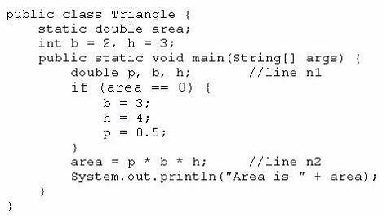

What is the result?

- Area is 6.0

- Area is 3.0
- Compilation fails at line n1

- Compilation fails at line n2.

Answer: D

QUESTION 39

Given the code fragment:
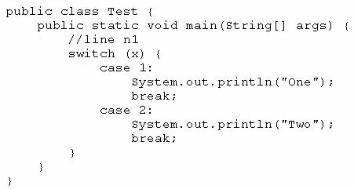

Which three code fragments can be independently inserted at line nl to enable the code to print one?

- Byte x = 1;

- short x = 1;

- String x = "1";

- Long x = 1;

- Double x = 1;

- Integer x = new Integer ("1");

Answer: ABF

QUESTION 40

Given:
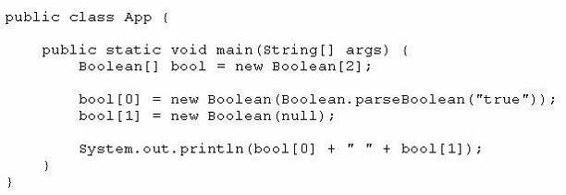

What is the result?

- True false

- True null

- Compilation fails

- A NullPointerException is thrown at runtime

Answer: A

Explanation:

With the statement “bool[1] = new Boolean(null);” we are creating a wrapped Boolean object with value null.

Java evaluates it to false since it cannot evaluate to true;

Question 41—Question 50
QUESTION 41

Given the following code for the classes MyException and Test:

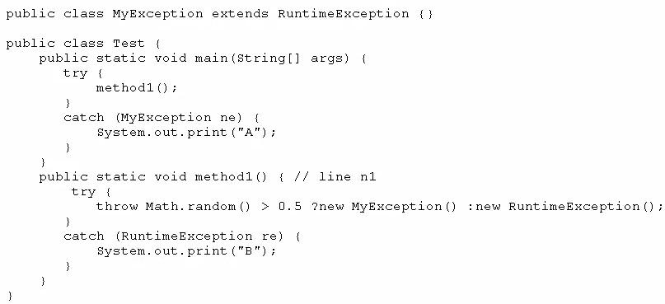

What is the result?

- A
- B

- Either A or B
- A B

- A compile time error occurs at line n1

Answer: B

Explanation:

“catch (RuntimeException re)” always catches a RuntimeException.

QUESTION 42

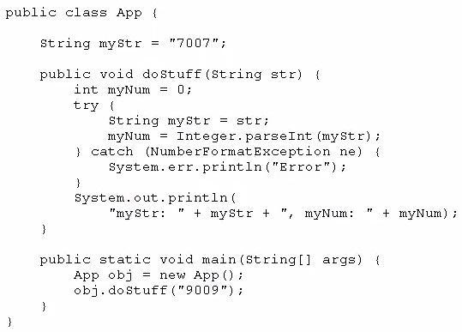
Given:

What is the result?

- myStr: 9009, myNum: 9009

- myStr: 7007, myNum: 7007

- myStr: 7007, myNum: 9009

- Compilation fails

Answer: C

QUESTION 43

Which two are benefits of polymorphism?

- Faster code at runtime

- More efficient code at runtime

- More dynamic code at runtime

- More flexible and reusable code

- Code that is protected from extension by other classes

Answer: CD

QUESTION 44

Given the code fragment:
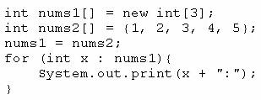

What is the result?

- 1:2:3:4:5:
- 1:2:3:

- Compilation fails.

- An ArrayoutofBoundsException is thrown at runtime.

Answer: A

QUESTION 45

Given:
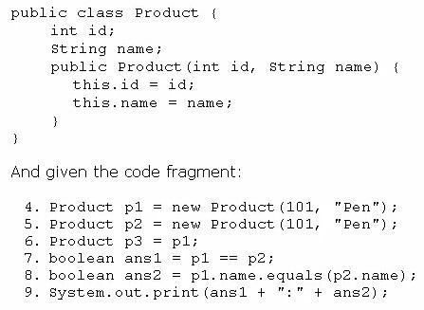

What is the result?

- true:true

- true:false

- false:true

- false:false

Answer: C

QUESTION 46

Given the following classes:
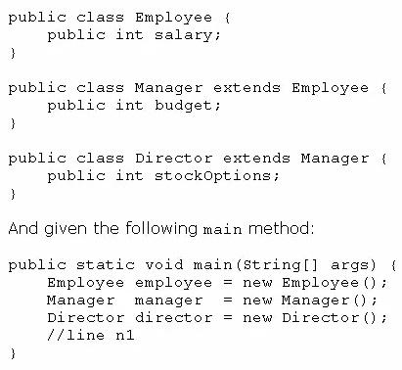

Which two options fail to compile when placed at line n1 of the main method?

- employee.salary = 50_000;

- director.salary = 80_000;

- employee.budget = 200_000;

- manager.budget = 1_000_000;

- manager.stockOption = 500;

- director.stockOptions = 1_000;

Answer: CE

Explanation:

C. budget is not a member of class employee.

E. stockOptions is not a member of class manager.

QUESTION 47

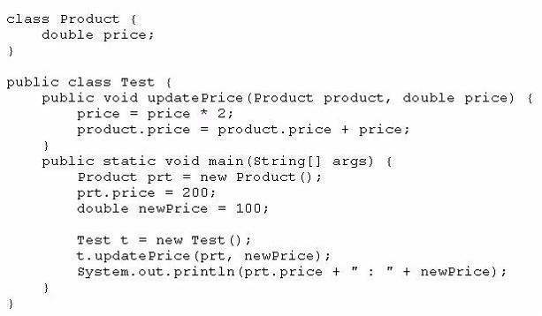
Given:

What is the result?

- 200.0 : 100.0

- 400.0 : 200.0

- 400.0 : 100.0

- Compilation fails.

Answer: C

Explanation:

After call to updatePrice prt.price change its value to 400 (prt is passed by reference)

variable newPrice never changes its value from 100 (newPrice is passed by value)

QUESTION 48

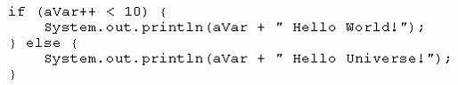
Given the code fragment:

What is the result if the integer aVar is 9?

- Hello World!

- Hello Universe!

- Hello World

- Compilation fails.

Answer: A

QUESTION 49

Given the code fragment:
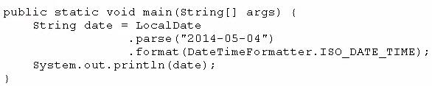

What is the result?

- May 04, 2014T00:00:00.000

- 2014-05-04T00:00: 00. 000

- 5/4/14T00:00:00.000

- An exception is thrown at runtime.

Answer: D

Explanation:

The exception java.time.temporal.UnsupportedTemporalTypeException is thrown at runtime.

We should use class LocalDateTime with ISO_DATE_TIME format or use the format

ISO_DATE to avoid the exception.

See ISO_DATE_TIME

QUESTION 50

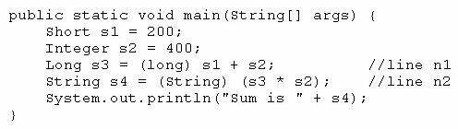
Given the code fragment:

What is the result?
- Sum is 600

- Compilation fails at line n1.

- Compilation fails at line n2.

- A ClassCastException is thrown at line n1.

- A ClassCastException is thrown at line n2.

Answer: C

Explanation:

Compilation fails at n2 because the compiler cannot cast long to String.

